**Experiment Title-1**

**Implement Exploratory Data Analysis on Any Data Set.**

**Student Name: ISHU RATTAN UID: 20BCS7755**

**Branch: BE-CSE Section/Group: 806/B**

**Semester: 5th Date of Performance:08/08/2022**

**Subject Name: Machine Learning**

**Subject Code: 20CSP_806**

**1. Aim/Overview of the practical:**

To Implement Data Exploratory Analysis.

**2. Task to be done/ Which logistics used:**

* Goggle colab (Online Complier)
* Jupyter Notebook (Offline)

**Hardware Requirement:**

* Window 10
* Power Supply
* RAM 4GB

**4. Steps for experiment/practical/Code:**

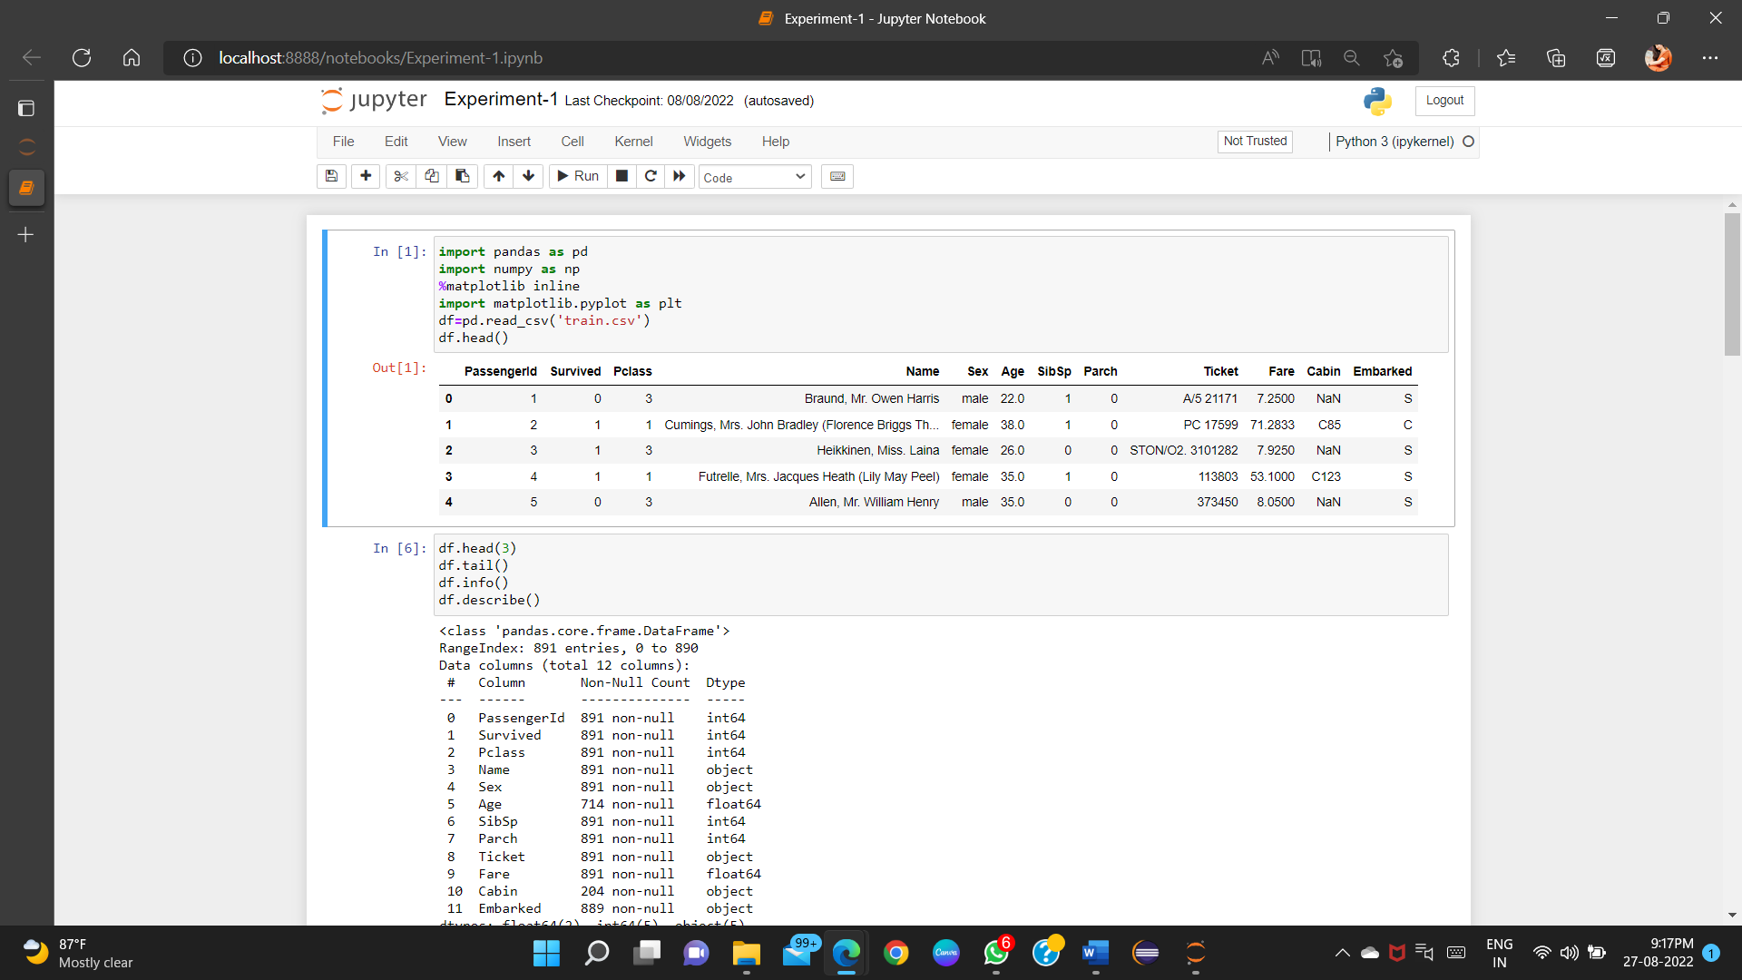

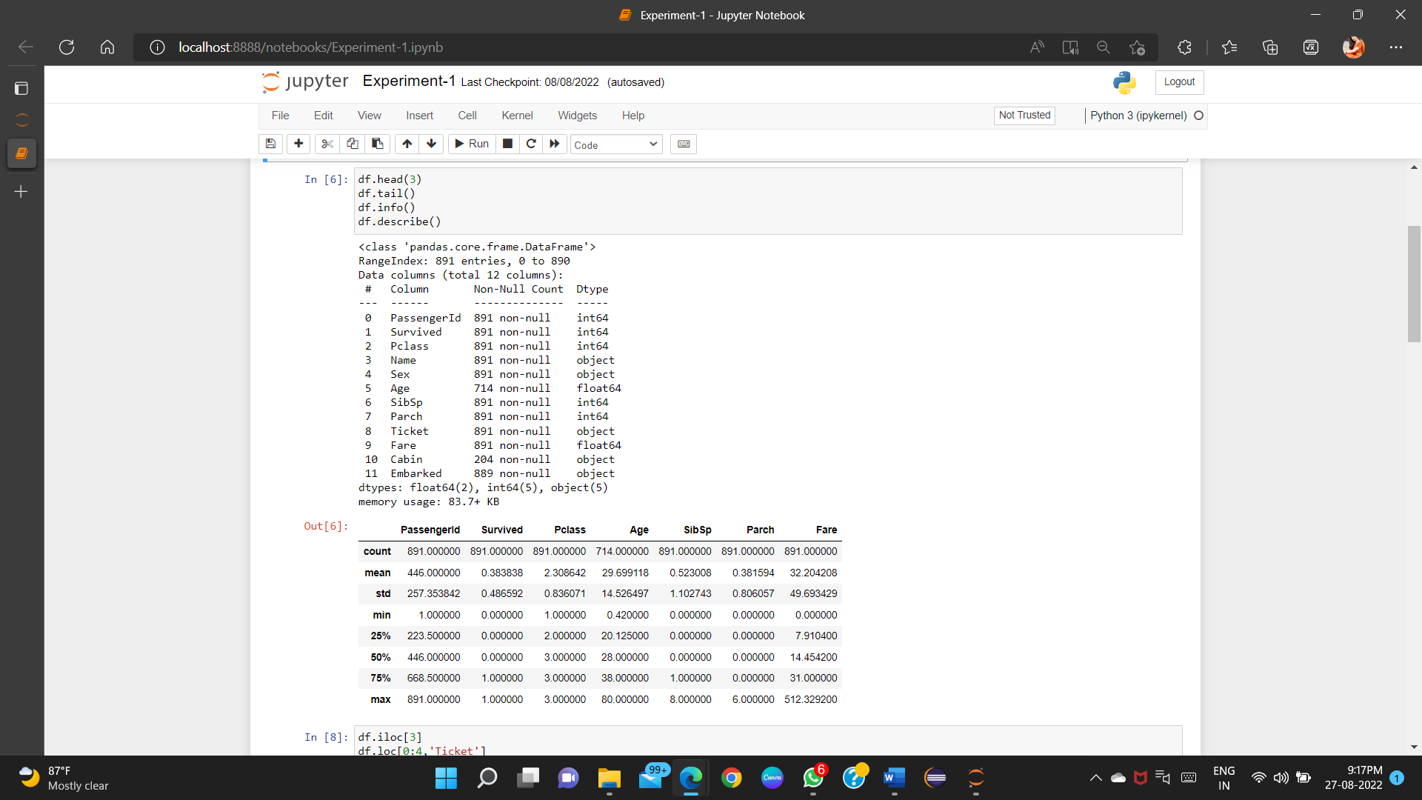

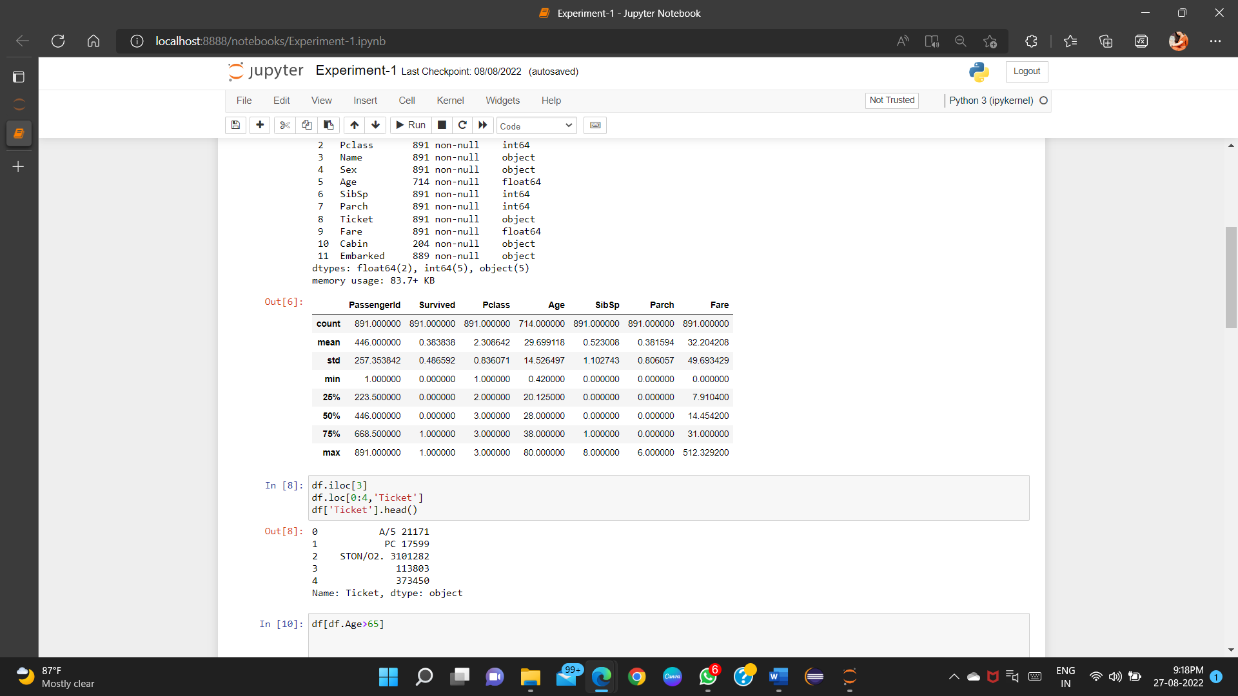

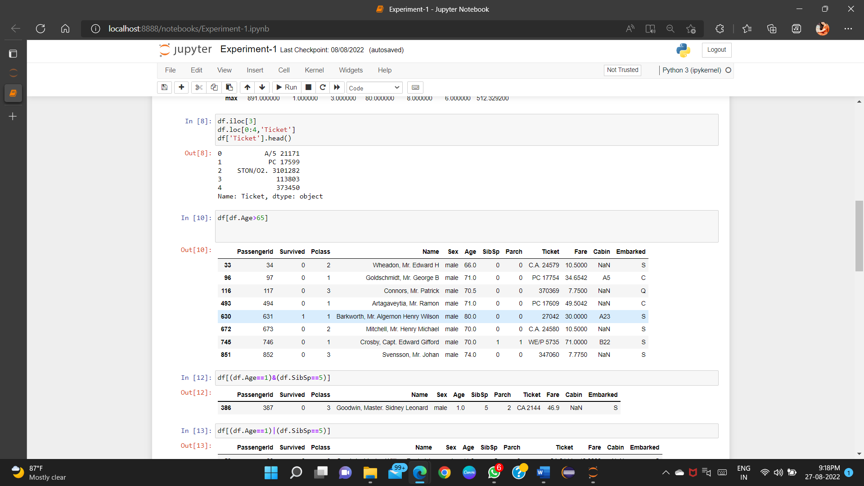

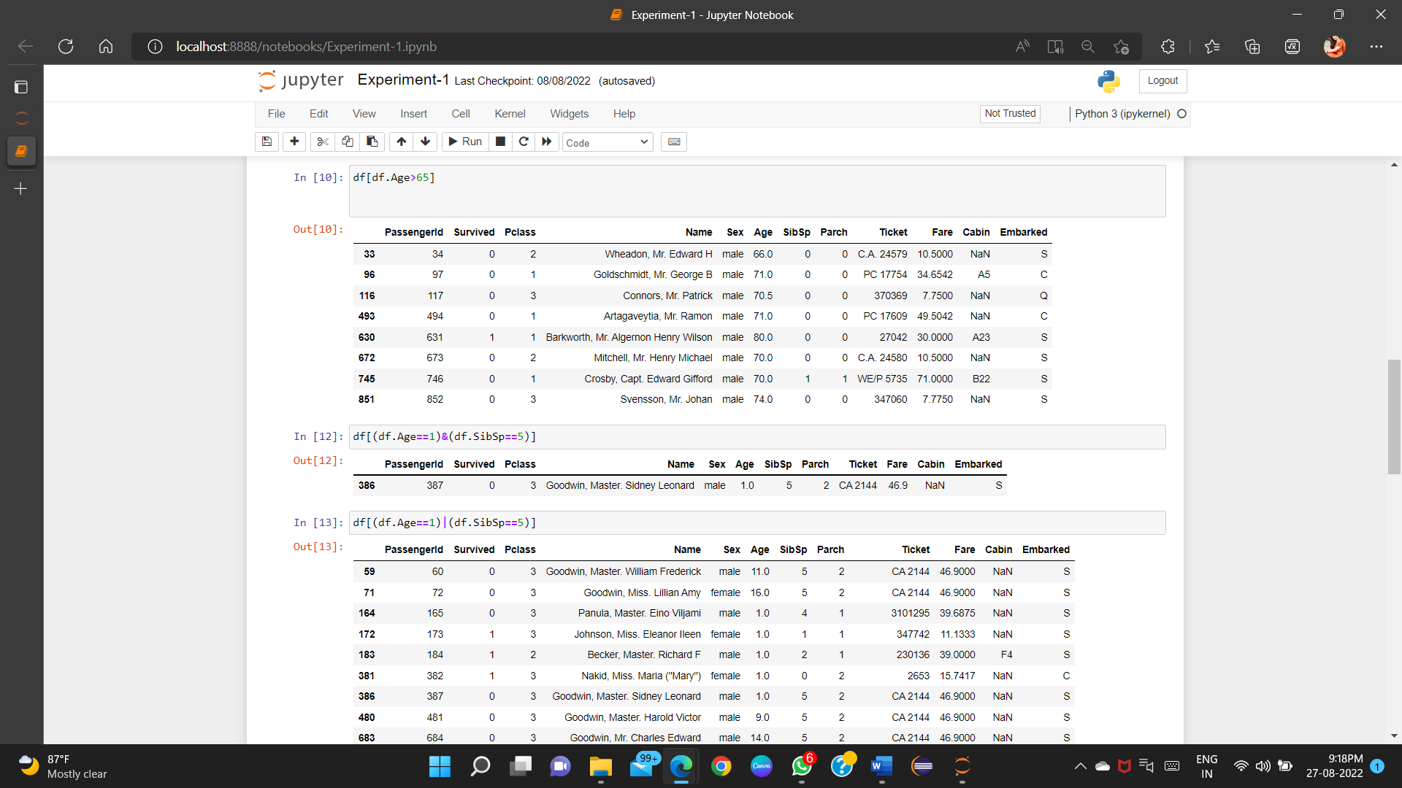

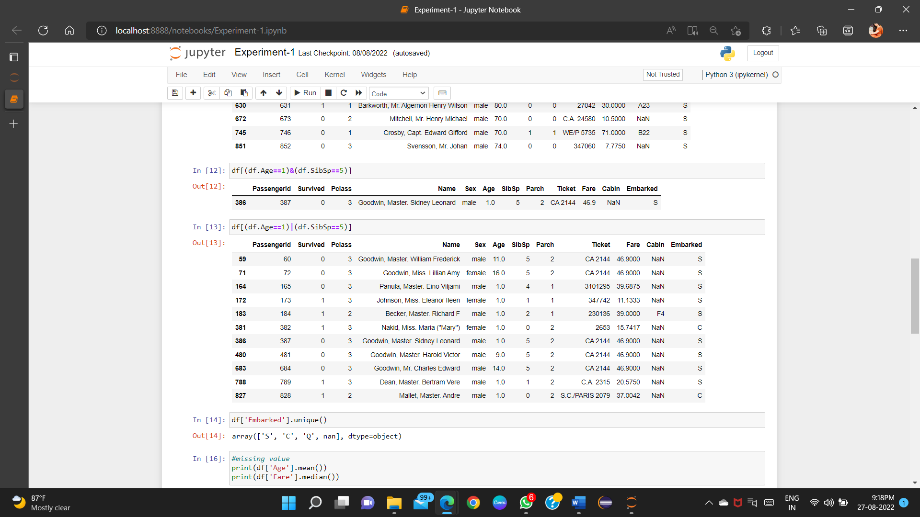

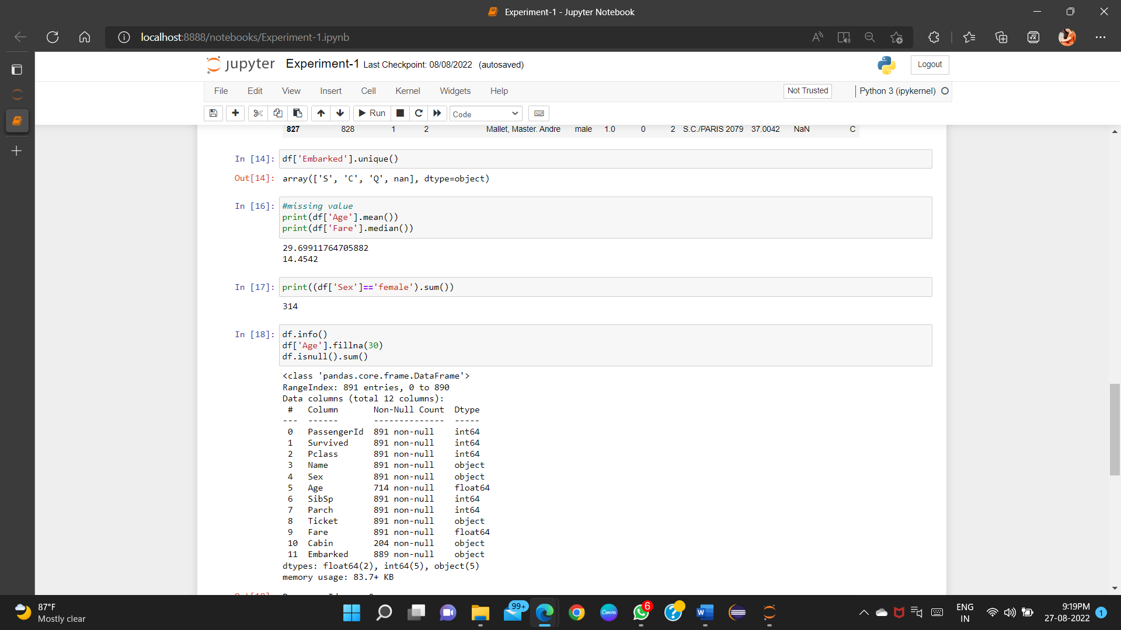

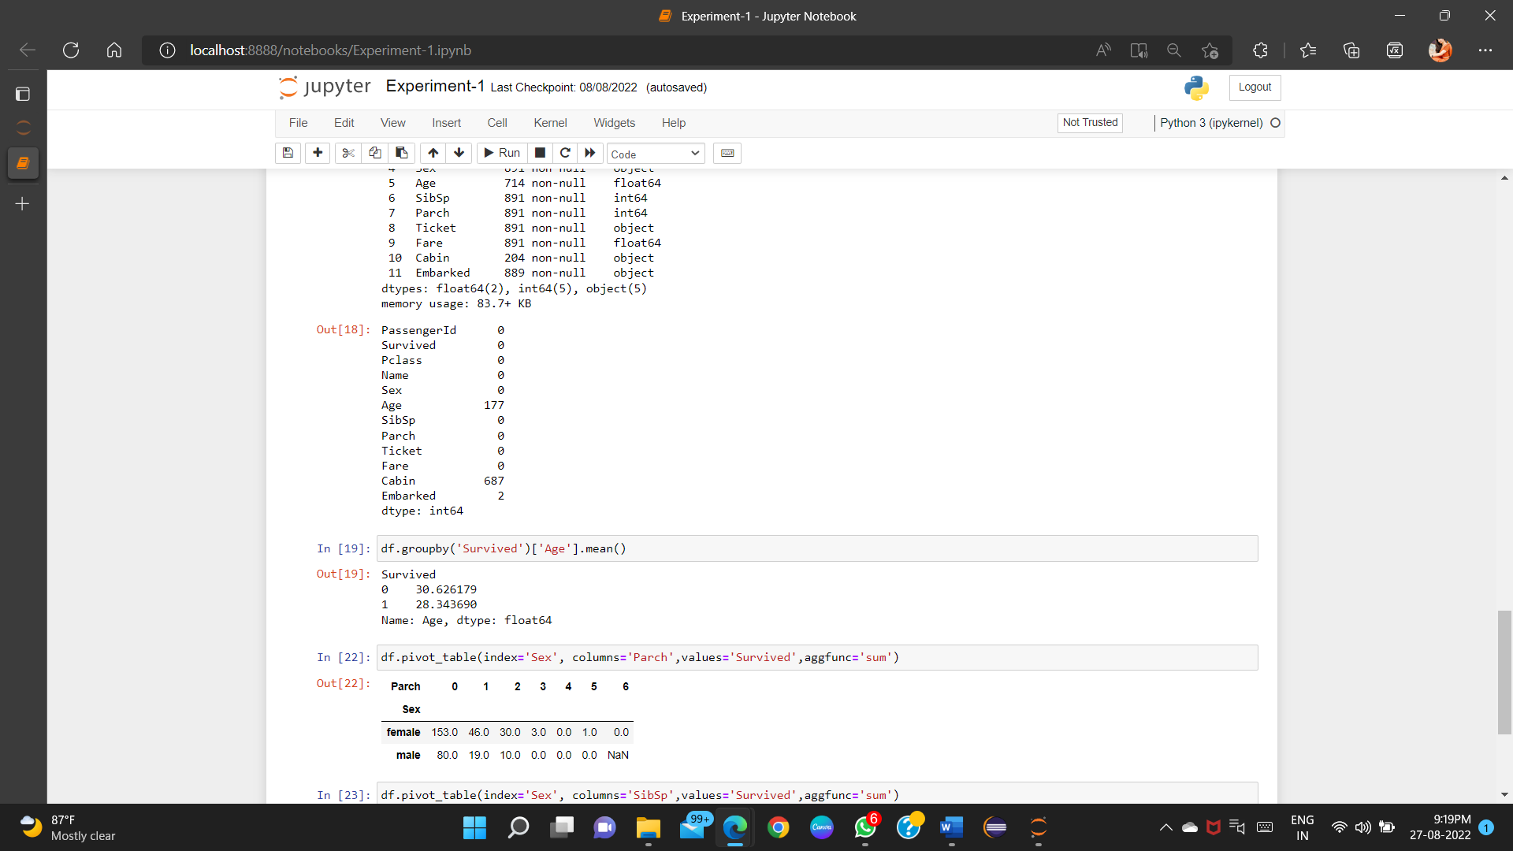

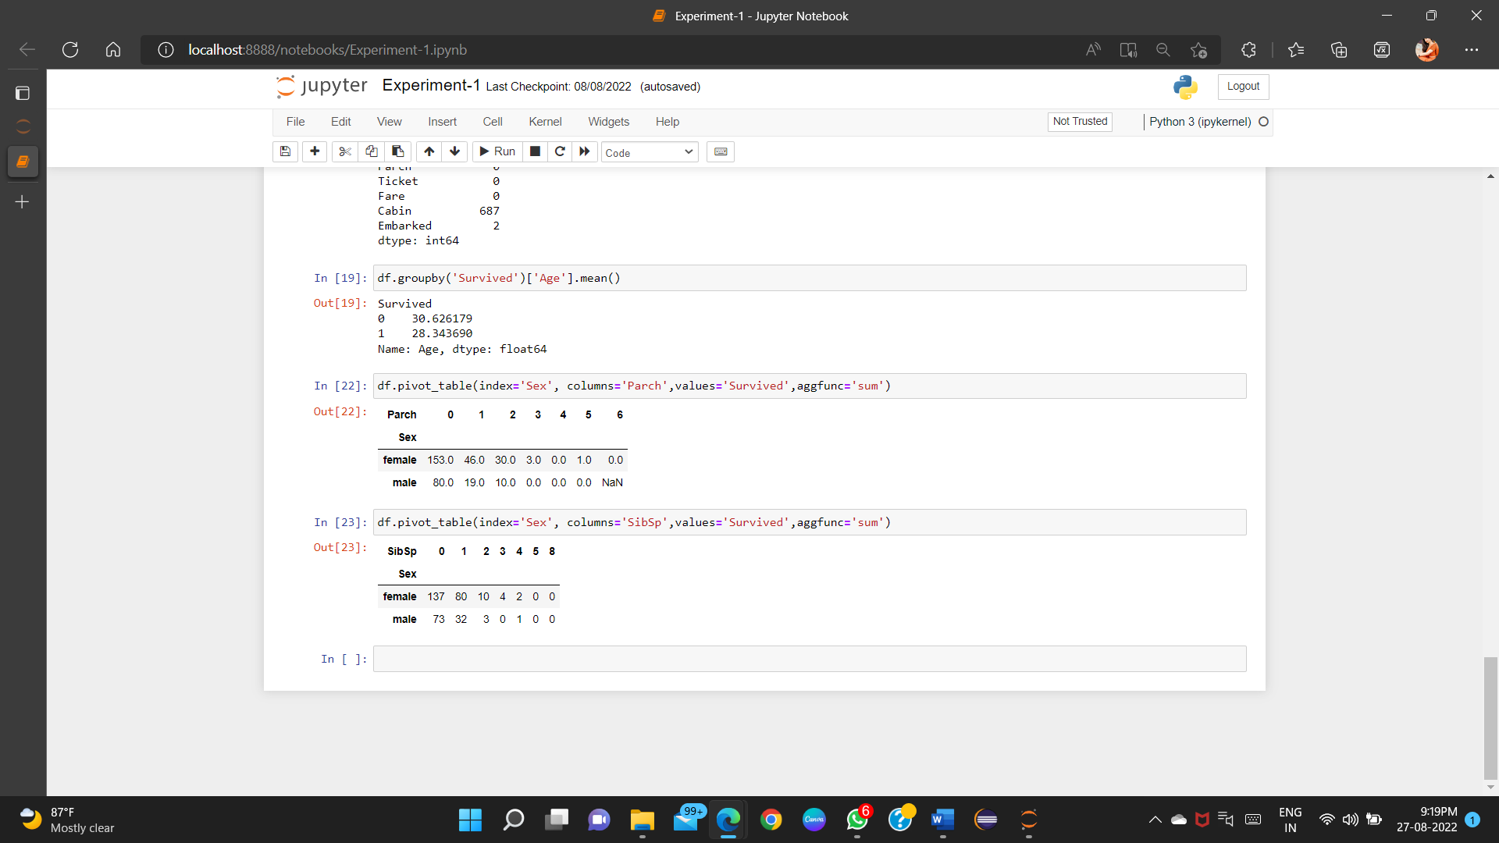

**Learning outcomes (What I have learnt):**

1. Learnt about Machine Learning

2.Learnt about how dataset is used.

3.Learnt about different types of commands

4.Learnt about how to use these commands on time.

**Evaluation Grid (To be created as per the SOP and Assessment guidelines by the faculty):**

|  |  |  |  |
| --- | --- | --- | --- |
| Sr. No. | Parameters | Marks Obtained | Maximum Marks |
| 1. |  |  |  |
| 2. |  |  |  |
| 3. |  |  |  |
|  |  |  |  |